Organize a Low-Cost Youth Art Contest
By Angela Cutrera, GFWC Arts and Culture Chairman
Taken from GFWC News & Notes edition on 3.10.2022
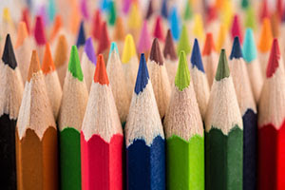
Color pencils are a popular media of art, thanks to companies such as Crayola and Prismacolor. Crayola is commonly used by school children and has potential to be used in more advanced capacities. Prismacolor is a high-quality, wax-based color pencil that is most commonly used in the professional art community.
Both brands have worked extensively to build awareness among children about all of the possibilities that a colored pencil can offer, which your club could build upon when organizing its Youth Art Contest.
Consider promoting how colored pencils are used to add layers onto paper. This allows the artist to create highlights, shades, and hues of many different kinds. Using a variety of pressure can greatly affect how much pigment and wax is being put onto the paper. Since colored pencils are generally inexpensive, they offer a practical and simple contest option.
Another low-cost option for a Youth Arts Contest is to judge watercolor painting. Watercolors are easy to use and are readily available. Mixing paints with a different amount of water can produce different results in pigment and thickness. Watercolor paintings should be judged by age group so that every child has the opportunity to do their best in the contest.
I look forward to reading about your Youth Art Contest projects on the GFWC Blog. Submit your success story write ups, action-packed photos, and if applicable, written consent from a parent or legal guardian of any children pictured to PR@GFWC.org.

