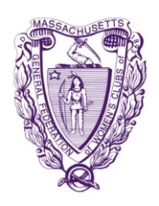
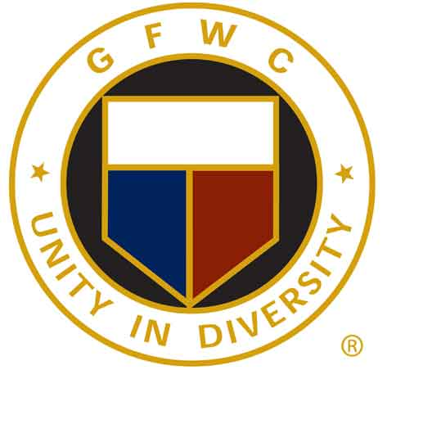
General Federation of Women's Clubs of Massachusetts
Lynne M. Stader, President

Website 2018-2020
Nancy Clark, Webmaster
9 Clarendon Street, Taunton, MA 02780
GFWCMA@live.com
508-823-8193

The GFWC of Massachusetts website is a valuable tool of organized content concerning all aspects of GFWC of MA. The website is a wonderful tool for our members to use for up-to-date information, which can used as a key component in your public relations outreach, membership recruitment and retention, program development, and operational planning. Please save the link to this website on your toolbar for quick and easy reference.

GFWC contest:
Website Contest:
Effective outreach to members and communities increasingly relies on the ability to share information online. Check out the criteria and enter your club's website.
Contest rules available at:
https://www.gfwc.org/wp-content/uploads/2018/06/2018-2020-Website-Contest.pdf
Submit Your Club's Events to our Website:
Does your club have an important club event, program or fundraiser coming up that you would like other Massachusetts clubwomen to know about? Use our GFWC of Massachusetts website, http://www.gfwcma.org/ to advertise your club’s events. Let our webmaster know via email, phone call, or mail.

This form is a handy reference for the information that you could include.
Website form for club event:
You can also find this form on our website at www.gfwcma.org/calendar.html.
Name of sponsoring club:
Name of event:
Date: |  | Time:
Place: |  |  |  |  |  | Address:
Price of tickets: |  |  |  | Benefit for:
Any other information:
The website is for you, the club members, so use it to your advantage!

