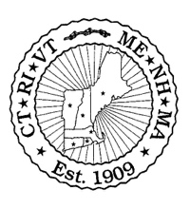
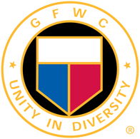
General Federation of Women’s Clubs

New England Region

FUNDRAISING EVENTS
MaryAnn Pierce, NER Fundraising Chairmen, GFWC Massachusetts

October 16, 2020 - Friday 6:00-7:00 pm “Zoom” Night Social activities:

New England Region Fundraiser “It’s in the Bag”
Each state is asked to be creative by filling a bag.
Suggestions include: Beach Bag, Tote, Vera Bradley Bag or something unique and fun with items related to the theme.
Each state has a different Theme.
The total value of bag items is requested at $100.00.
States should send a photo to MaryAnn Pierce of their bag with a list of the contents.
Chances for NER “It’s in the Bag” are 3 Chances for $10.00 and 7 Chances for $20.00.
Tickets will all be placed in one drawing. No choice on bag to win.
Winners will be announced October 17, Saturday during NER.

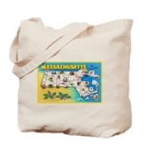
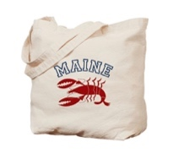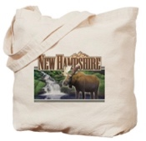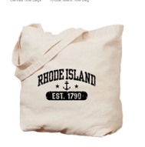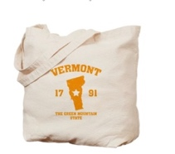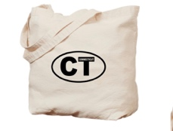
Magical in MA. Mystical in ME. Naughty in NH. Relaxing in R.I. Vivacious in VT. Cozy in CT.

Fundraiser for the GFWC Capital Campaign
This is a competition for creativity and success amongst the Regions.
Let's make New England Region stand out!!
Pearls of Wisdom
Each chance you purchase gives you a virtual strand of pearls .
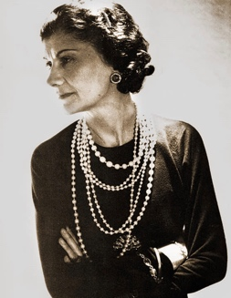
When the time comes, pick heads or hearts: a toss of the coin will decide which it will be.
When you run out of strands, you are out of the game.
The game continues until one is left: that person will win half the sales of the virtual pearls.
The more strands you purchase better your chances of winning.
Flaunt your Pearls on “Zoom.”
Pearls $5.00 a strand.
Winner announced Friday night.

“GFWC is a Class Act”
#I amGFWC

Use this form to order your chances.

All Fundraising Opportunity purchases must be made in advance and received no later than 10/10/20.
- Please send in this form when purchasing your chances.
- Separate checks are appreciated for each fundraiser.
- Checks made payable to GFWC New England Region.
- Send checks and this form to:
MaryAnn Pierce, Chairman, 161 Harris Ave, Needham, MA 02492

-----------------------------------------------------------------------------------------------------------

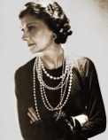
“Pearls of Wisdom” to support Capital Campaign #IamGFWC
This is a Fundraiser that all Regions are participating in.
Let’s show how New England Region can have great fun and connect with our GFWC Sisters while supporting GFWC Headquarters.
$5.00 each for a virtual strand of pearls.

Name:______________________ _______________________

Address:____________________________________________

Phone:________________ Email:________________________

Number of Strands purchased:_______

Total amount for "Pearls for Wisdom"_______

-----------------------------------------------------------------------------------------------------------

“It’s in the Bag” New England Region Fundraiser
Thank you to each state for donating their bag.
Tickets will all be placed in one drawing. No choice on bag to win.
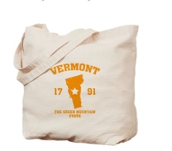
Chances are 3 for $10.00 and 7 for $20.00.
Name:_________________________________________

Address:_______________________________________
Phone:________________ Email:___________________

Number of Chances purchased:_______

Total amount for "It's In the Bag" _______

Total amount included for both fundraisers _______

