General Federation of Women's Clubs of Massachusetts
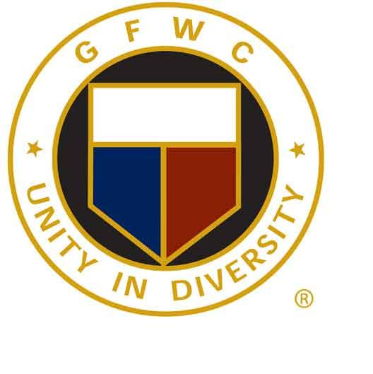
T Jablanski, President

Membership ~ 2022-2024
A. Elaine Brickman, Chairman
142 Quanset Road, Orleans, MA 02653
aelainebrick@gmail.com
732-668-5584 (C)

GFWC Massachusetts Clubwoman of the Year Nominee
The award is an occasion to highlight extraordinary Massachusetts clubwomen who are standouts in your club. When nominating, you should think of considering the clubwoman who has gone above the call of duty for her club, who almost always says “yes” to further the goals of your club, who takes on roles both as follower and leader, who represents her club in the most positive light, and who always promotes the club and its activities.

Consideration should be given to those women who are not always in the spotlight, but those who are tireless through their roles as volunteers within their clubs.

Clubwoman Entry Qualifications:
- Maintained membership in a woman's club for at least two years.
- Someone who has gone above and beyond a club's membership expectations.
- The member who always says "yes", no matter how full her plate is.
- Someone who is a leader and a follower, a team player, supporting and representing her club well.
- Someone who is a standout clubmember in many ways, always representing the club in a good light and promoting the club and its activities.
Nomination for this award is an honor and all those nominated and the nominee chosen will be honored at Annual Convention, 2023.

Entry Information:
- One entry per club. Former state winners of this award are not eligible.
- Entries must be typed, double spaced and no more than two (2) pages.
- Include a cover page: club name, address and Club President's name.
- Mail completed entry postmarked by April 1st to:
- Elaine Brickman
142 Quanset Road
Orleans, MA 02653
or by email to: aelainebrick@gmail.com

