GFWC 2020-2022 Education and Libraries

Chairman: Tina Neese, Ed.D., LPC

tinadaniel1224@gmail.com 678-458-0337
Volume Twenty One April 2022 Newsletter

Inside this edition
- ESO Facebook
Group
- Featured Monthly Book
- Talk It Up
Tuesdays
- Well Read Wednesdays
- Honorary Chairman
Others news in this edition
- Book List Recommendations
- App Ideas
- Challenge Project
- Resources

Read All About It!

ESO Facebook Book Group
The Education and Libraries ESO Facebook Book Group meets online to discuss various books. There will be a featured book each month. The month of April features “Every Little Thing” by Mary Lou Sanelli. During the month on Tuesdays, readers are encouraged to post their thoughts on our “Tuesday Chats” on the ESO private Facebook page, as well as participate in the live interviews and workshops presented by the author.

Not an ESO member yet? What do I do?
Request to be added to the GFWC 2020-2022 ESO Book Club on Facebook. Order or download your book. Read and discuss the book on the group page during the month. Join the 1,000 plus members on the page who are loving the chance to read together!

In April remember these dates:
Talk It Up Tuesdays – April 5, 12, 19 and 26
April 12th – Facebook Live event with the author!
Participate in discussing our book of the month

Honorary Chairman

Jane Jenkins Herlong

Jane Jenkins Herlong is Education and Libraries’ honorary chairman for the 2020-2022 Administration. Jane is an author, inspirational speaker, and entertainer. Jane is also available to encourage our women with humor and wisdom through speaking engagements.

Jane has published four books: Rhinestones on My Flip-Flops, Bury Me with My Pearls, What Ta-tas Teach Us and Bare Feet to High Heels.

Wanting more of Jane? Invite her to your state or watch her videos, such as this one: Jane.

Our last and final ESO book club selection will be in May and will be “…And Ladies of the Club” by Helen Hoover Santmyer.

April’s Book:
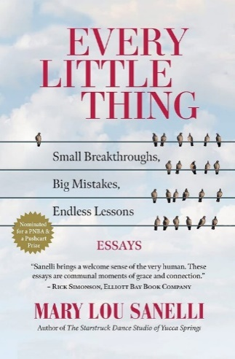
Join author Mary Lou Sanelli on Facebook live on April 12 at 7:00 PM EST to learn more about her book and writings.
In Every Little Thing: Small Breakthroughs, Big Mistakes, Endless Lessons, Sanelli proves that a narrative essay can be wise and vulnerable and nail what matters most in our lives, all in the same breath. No one tells-truth with more heart, humor, and accountability. With a voice that speaks of life as it is everyday lived—with joy, calm, worry, and alarm—Sanelli manages to write lyrically in warm, accessible language. One can learn so much from a writer who, wherever she goes she takes her readers along with her, her experiences becoming theirs, as well. These writings will make you miss the Northwest even if you've never been there. Gliding on sentences smooth as stone with the brightness of the author's enthusiasm, this book will delight, challenge, reassure, and steer any reader toward a higher capacity to expand life’s smallest moments into our grandest triumphs.

“That’s the thing about books. They let you travel without moving your feet,” Jhumpa Lahiri

At various times on the ESO Book Group Page on Facebook, there will be a book list released for members to review and add to their “TBR” list. Members can comment about books on the list, giving others an idea about the book.

It is April! Here’s some books to add to your reading list:

- Klara and the Sun by Kazuo Ishiguro
- But You're Still So Young: How Thirtysomethings Are Redefining Adulthood by Kayleen Schaefer
- Infinite Country by Patricia Engel
- Justine by Forsyth Harmon
- The Committed by Viet Thanh Nguyen
- The Ghost Variations by Kevin Brockmeier
- The Arsonists’ City by Hala Alyan
- Women and Other Monsters: Building a New Mythology by Jess Zimmerman
- The Seed Keeper by Diane Wilson
- My Heart by Semezdin Mehmedinovic
- The Fourth Child by Jessica Winter
- My Friend Natalia by Laura Lindstedt
- Of Women and Saly by Gabriela Garcia
- The Five Wounds by Kirsin Valdez Quade
- Hummingbird Salamander by Jeff VanderMeer
- Blow Your House Down: A Story of Family, Feminism, and Treason by Gina Frangello

STEM Activities for April!

April is all about Spring and Easter holidays and is a great time to implement some fun STEM (Science, Technology, Engineering and Mathematics) activities with children.

Here are some fun activities to try if you celebrate Easter:

Find these fun STEM Easter-themed activities at https://www.science-sparks.com/easter-stem-challenges/:
Eggy Zip Wire
Save the Egg
What Does it Weigh
Magnet Powered Egg Cars
Eggy Toothpick Towers
Catapult an Egg
Egg Chain Reaction
Pneumatic Opening Egg

Find more here:

https://www.steamsational.com/easter-stem-activities/

https://www.fantasticfunandlearning.com/make-crystal-egg-easter-craft.html

iday Activities in the ClassroomAwards! Awards! Awards!
Important Dates in April
April Autism Awareness Month
Math Education Month
National Poetry Month
National Turn Off the TV and Read Month
National School Library Media Month
April 10-16 Week of the Young Child sponsored by the National Association for the Education of Young Children
Idea: Host a healthy eating event by providing a “cookbook” with healthy recipes to families at a local event. Teach children how to read a recipe and make the snack.
National Library Week
Honor your local library staff with treats or gift cards. Send them thank you notes.
April 2: International Children’s Book Day
April 4: Easter
April 5: National Read a Road Map Day
April 5: National Library Workers Day
April 6: National Library Outreach Day
April 7: World Health Day
Take Action for Libraries Day
April 10: Encourage a Young Writer Day
April 12: Beverly Cleary’s birth day
D.E.A.R. (Drop Everything and Read) Day
April 14: Webster’s Dictionary published
April 18: Paul Revere’s Famous 1775 Ride
April 21: National Kindergarten Day
April 22: Take our daughters and sons to work day
Earth Day
Girl Scout Leader Appreciation Day
April 23: William Shakespeare’s birthday
April 24: Library of Congress established 1800
April 30: Arbor Day
Provide books to children, schools or libraries on trees. Teach about native trees in your area.

Ways to get involved in Autism Awareness Month.

Sponsor and donate autism toys and sensory tools to classrooms or family in need. Offer a weighted blanket, compression vest, fidget or chewy tool.

Raise awareness and become a sensory savvy advocate on the benefits of a sensory room and how they help students to self-regulate.

Attend or host an event for Autism Awareness Month.

Post facts on puzzle pieces around your community.

Watch a movie as a club about autism (Life Animated, Autism the Musical, Best Kept Secret, Family Next Door, or Rain Man)

Technology App Monthly Recommendation:
Best Apps for Skill Development for Autism
Proloquo2Go icreate…Social Skills Stories
Speech Blubs 2 Language Therapy for Kids MITA
Otsimo ABA Autismo
Facts about Autism
- Every 20 minutes someone is diagnosed with autism
- Individuals with autism may use a variety of different and unique ways to communicate
- Many students on the spectrum will stay in school until they are 21
- People with autism have special gifts and talents to offer
Thank you to all chairmen who submitted their award entry forms by March 15. I have thoroughly enjoyed reading the submissions and look forward to presenting the awards in June at the GFWC Convention in New Orleans, Louisiana.

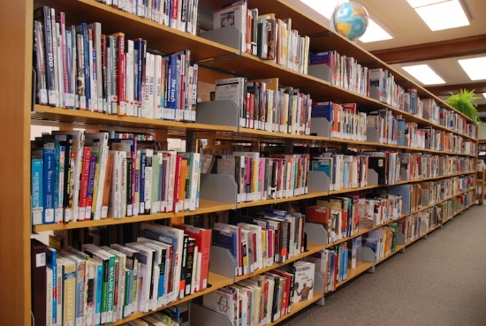
April 3 – 9 is National Library Week
National Library Week (April 3 - 9, 2022) is a time to celebrate our nation's libraries, library workers' contributions and promote library use and support. First sponsored in 1958, National Library Week is sponsored by the American Library Association (ALA) and observed in libraries across the country each April. All library types are recognized during this week – schools, public, or colleges.
In the mid-1950s, research showed that Americans were spending less on books and more on radios, televisions and musical instruments. Concerned that Americans were reading less, the ALA and the American Book Publishers formed a nonprofit citizens organization called the National Book Committee in 1954. The committee's goals were ambitious. They ranged from "encouraging people to read in their increasing leisure time" to "improving incomes and health" and "developing strong and happy family life." With the cooperation of ALA and with help from the Advertising Council, the first National Library Week was observed in 1958 with the theme "Wake Up and Read!"
Remind your community how important it is to fund libraries as Congress develops their annual budget proposal. Use the hashtag #FundLibraries.
Learn more about the Build America’s Libraries Act.
Invite your members of Congress to virtual tour your library. Showcase how your local library impacts your community.
Take your library out into your community! Talk to a local church or school about using a bus or van to be a bookmobile! Stop at local elementary schools, community homes, assisted living places, low income residences, or senior living apartments. Make any place a library pop-up. Pop-up at community events!
Thank your local library staff. Provide a luncheon, goody basket, thank you cards, gift cards, donuts, etc. and make them feel special for what they do in the library.
April is also SCHOOL LIBRARY MONTH! School librarians are encouraged to host events to help their school and local community celebrate the essential role strong school libraries play in transforming learning. School Library Month was first observed in 1985 and the theme was “Where Learning Never Ends”.
Ways to help your local school libraries this month:
- Host a day when you read to classes for the librarian.
- Have a book drive and give the books to young children in the school.
- Give them a “book shower”.
- Donate monies for them to purchase library quality books.

