GFWC 2020-2022 Education and Libraries

Chairman: Tina Neese, Ed.D., LPC

tinadaniel1224@gmail.com 678-458-0337
Volume Fifteen October 2021 Newsletter

Inside this edition
- ESO Facebook
Group
- Featured Monthly Book
- Talk It Up
Tuesdays
- Well Read Wednesdays
- Honorary Chairman
Others news in this edition
- Book List Recommendations
- App Ideas
- Challenge Project
- Calendar & Meeting Dates
- Resources
- Creative Projects for Award Entries

Read All About It!

ESO Facebook Book Group
The Education and Libraries ESO Facebook Book Group meets online to discuss various books. There will be a featured book each month. The month of October features The Guernsey Literary & Potato Peel Pie Society by Shaffer and Barrows. Watch the movie and compare it to the book for comments on our page. During the month on Tuesdays, readers are encouraged to post their thoughts on our “Tuesday Chats” on the ESO private Facebook page.

Not an ESO member yet? What do I do?
Request to be added to the GFWC 2020-2022 ESO Book Club on Facebook. Order or download your book. Read and discuss the book on the group page during the month. Join the 1,000 members on the page who are loving the chance to read together!

In September remember these dates:
Talk It Up Tuesdays – October 5, 12, 19 and 26
Post your thoughts about the book on Tuesdays.

Our November novel: Grace & Grit by Lilly Ledbetter (featured GFWC Convention speaker).

Honorary Chairman

Jane Jenkins Herlong

Jane Jenkins Herlong is Education and Libraries’ honorary chairman for the 2020-2022 Administration. Jane is an author, inspirational speaker, and entertainer. Jane is also available to encourage our women with Southern humor and wisdom through speaking engagements.

Jane has published four books: Rhinestones on My Flip-Flops, Bury Me with My Pearls, What Ta-tas Teach Us and Bare Feet to High Heels.

Wanting more of Jane? Invite her to your state or watch her videos, such as this one: Jane.

I am excited about the October novel. My mother is British and lived during WWII. She recalls the planes flying over her village, hiding in the cellar and under tables during the bombing. She visited the island, although during my trips to see family, it was not a place I have. It is now on my travel bucket list! As this novel is set after the war, I am curious as to how this will handle post war Europe.
October’s Book – The Guernsey Literary and Potato Peel Pie Society by Shaffer and Barrows
January 1946: London is emerging from the shadow of the Second World War, and writer Juliet Ashton is looking for her next book subject. Who could imagine that she would find it in a letter from a man she’s never met, a native of the island of Guernsey, who has come across her name written inside a book by Charles Lamb.
As Juliet and her new correspondent exchange letters, Juliet is drawn into the world of this man and his friends—and what a wonderfully eccentric world it is. The Guernsey Literary and Potato Peel Pie Society—born as a spur-of-the-moment alibi when its members were discovered breaking curfew by the Germans occupying their island—boasts a charming, funny, deeply human cast of characters, from pig farmers to phrenologists, literature lovers all.
Juliet begins a remarkable correspondence with the society’s members, learning about their island, their taste in books, and the impact the recent German occupation has had on their lives. Captivated by their stories, she sets sail for Guernsey, and what she finds will change her forever.
An older novel, the book was published in 2008. It was made into a movie in 2018. Part of this month’s reading is to also watch the movie to compare the literary version with the screen version.
“That’s the thing about books. They let you travel without moving your feet,” Jhumpa Lahiri

At various times on the ESO Book Group Page on Facebook, there will be a book list released for members to review and add to their “TBR” list. Members can comment about books on the list, giving others an idea about the book.

It is October! Here’s some FALL books to add to your reading list:

- Inseparable by Simone de Beauvoir
- Matrix by Lauren Groff
- Poet Warrior by Joy Harjo
- Beautiful World, where are you? By Sally Rooney
- The Magician by Colm Toibin
- Harlem Shuffle by Colson Whitehead
- The Book of Form and Emptiness by Ruth Ozeki
- Cloud Cuckoo Land by Anthony Doerr
- A calling for Charlie Barnes by Joshua Ferris
- Believing: Our Thirty-Year Journey to End Gender Violence by Anita Hill – watch for this one on our ESO book club list soon!
- What Storm, What Thunder by Myriam J.A. Chancy
- Crossroads by Jonathan Franzen
- Fight Night by Mirian Toews – this looks like an interesting read about women uniting to fight their abusers
- Dear Memory by Victoria Chang
- Oh William! by Elizabeth Strout
- My Body by Emily Ratajkowski

STEM Activities with Dinosaurs!

Children can learn about fossils and archaeology while practicing counting, sorting, and fine motor skills. This theme lends itself well to sensory activities.

Here’s some STEM activities to learn about dinosaurs:

Dinosaur Stomp and Ice Escape

Build A Dino

Dinosaur crafts

Inventors of Tomorrow

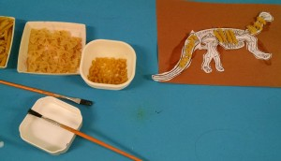

Here are some children’s books to tie into a dinosaur themed activity:

Oh Say Can you Say Di-no-Saur? By Bonnie Worth; How to Catch a Dinosaur by Adam Wallace; We don’t eat our classmates by Ryan Higgins; Little Kids first Big book of Dinosaurs by Catherine Hughes; Dino Racing by Ace Landers; Dinosaur Dance! By Sandra Boynton; and Tiny T. Rex and the Impossible Hug by Jonathan Stutzman.
International Dinosaur Month
Important Dates in October
Month of: Bully Prevention Month, Computer Learning Month, Global Diversity Awareness Month, Family History Month, International Dinosaur Month, Month of the Young Adolescent
Fire Prevention Week Oct 3-9 – help your local daycares/schools with sponsorship (bookmarks, coloring pages, etc); National Metric Week (10-17); National School Lunch Week (11-15): “Wild About School Lunch:, info at https://schoolnutrition.org/; National Safe Schools Week (17-23); National Character Counts Week (17-23); National School Bus Safety Week (18-22); Teen Read Week (10-16).
Oct 1 BOOK IT! Program begins. Read more about the program here: https://www.bookitprogram.com/.
Oct 1-2 National Storytelling Festival (virtual 2021) – join at https://www.storytellingcenter.net/festival/main/.
Oct 2 Mohandas Gandhi birthday (1869)
National Custodial Day – take treats to your local school systems custodians!
Oct 3 Premiere of several long standing family and children’s television shows: Andy Griffith Show (1960), Captain Kangaroo (1955), and Mickey Mouse Club (1955)
Oct 4 First successful human-made satellite was launched by the Soviet Union in 1957 (great STEM activity)
Oct 5 Robert Goddard birthday (1882), Father of Modern Rocketry (great STEM launch)
Oct 6 National Walk to School Day
Oct 9 National Newspaper Carrier Day
Oct 11 First Lady Eleanor Roosevelt birthday (1884)
Oct 12 Columbus Day
Oct 15 Poetry Day
My Mom is a Student Day
Oct 16 Noah Webster birthday (1758) & Dictionary Day
Oct 17 Black Poetry Day
Oct 23 Make a Difference Day
Oct 30 Emily Post Birthday – teach etiquette to children!
Oct 31 Halloween
National UNICEF Day – promote with young children

It’s dino time! Libraries and schools across the country will be full of great books, movies and documentaries about our favorite larger than life reptiles! The word “dinosaur” means terrible lizard and many do look ferocious. Whether fearsome or placid, dinosaurs intrigue adults and enthrall school aged students. Bring dinosaurs to classrooms and libraries and take advantage of this high-interest topic!

Dinosaurs first appeared on the Earth 230 million years ago. Different species lived at different times. Dinosaurs can be used to introduce students to the concept of geologic times periods. For example, the Stegosaurus lived during the early Jurassic period. Make timelines with children to map different species and time periods. Children can then visually see how long dinosaurs lived on Earth compared to the relatively short time people have.

Students can learn the principles of scientific classification by sorting dinosaurs. Divide by two legged or four. Divide by meat-eaters or plant-eaters. Other ways to sort: horned, big and little, water and land. Use picture cards the club makes and laminates. Here is a way to introduce terms such as like, similar, different.

Dinosaur poetry is always fun! Dinosaur Rap from Rock ‘n Learn has catchy rhythms and Bone Poems by Jeffrey Moss has several funny poems to stimulate creative thought.

Studying fossils and how they are made is an offshoot of dinosaur units. Create your own fossil dig for classrooms with a large box, plaster of Paris, a few bones, some leaves and some soil. Here’s a way to make those fossils

https://www.littlepassports.com/blog/craft-diy/make-dinosaur-fossils-using-salt-dough/. Use chisels or dental instruments to create a classroom dig, where the student removes one layer at a time.

Here are some literature connections: Dinosaur Babies by K. Zoehfeld, A Dinosaur named Sue by F. Robinson, and Did Dinosaurs live in your backyard? By M. Berger.
World Poetry Day, October 15
Disability Impacts All of Us!
*61 million adults in the US live with a disability
*15% of the world’s population have a disability
*26% of adults in the US have some type of disability, meaning one in four
*The percentage of people living with disabilities is highest in the South
*Percentage of adults with functional disability types:
13.7% Mobility (serious difficulty walking/climbing)
10.8% Cognition (serious difficulty concentrating,
Remembering or making decisions)
6.8% Independent Living (difficulty doing errands)
5.9% Hearing (deafness/serious hearing difficulty)
4.6% Vision (blindness/serious difficult seeing)
3.7% Self-Care (difficulty dressing or bathing)
2 in 5 adults 65 or older have a disability
1 in 4 women have a disability
Adults with disabilities are more likely to have obesity, smoke, have heart disease and diabetes.
Find more information at cdc.gov.
Technology App Monthly Recommendation:
Best technology websites for beginners for genealogy in honor or Family History Month
Family Tree Builder
Ancestry.com
Ask a Librarian (ask.loc.gov)
HeritageQuest Online
Universal Class

Quotes about Disability:
“There is no greater disability in society than the inability to see a person as more.” Robert Hensel
“Disability is the inability to see ability.” Vikas Khanna
“Autism is not a disability. It’s a different ability.” Stuart Duncan
“A hero is an ordinary individual who finds the strength to persevere and endure in spite of overwhelming obstacles.” Christopher Reeve

Want some unusual or humorous titles to stimulate creative writing?
- Mr. Goblin’s First Halloween
- The Right Way to Make Bat Wing Stew
- How the Raccoon Got his Mask
- Runaway Pumpkin
Help a class write a class poem. Use the couplet or two-line rhyming poem. Provide the first sentence to the class. Then brainstorm words that rhyme with the last word in the line. The class creates the second line. After practicing, pair students to write and illustrate their own poems.
Example: There once was a ghost who sat on a post.
Another poetry form is the cinquain, which is composed of five lines and each line does something different. Work with the class to brainstorm ideas and compose a class poem. Here is the outline for a cinquain:
- Title (use one word)
- Describe title (use two words)
- Describe an action (use three words)
- Describe a feeling (use four words)
- Refer back to the title (use one word)
Ways clubs can do activities in October to celebrate Fall and Halloween.
Clubs can adopt a classroom (virtual or in person) and assist with some science, math or language arts activities.
Set up a display table with a number of pumpkins that vary in size and shape. Include some books on Halloween or jack-o-lanterns. Read stories to the students (in person). Record stories for the students (virtual).
Brainstorm what students know about pumpkins. List on the board (in person). Have students write and place on the board or in a jar to review (virtual).
Have students grouped into small groups of five. Provide the same size pumpkin to each group. Have them estimate the weight and then have them weigh (comparison chart). Have them estimate how many seeds and record on a chart. Then, cut the pumpkin in half and count the seeds (comparison chart). To reinforce place value concept, provide a paper plate and have them group by 10’s.
Support writing by supplying the first line of a poem and have students complete. Use pumpkin cut outs for students to write on. Example starters: Clever pumpkin, fat and cute…, Six little pumpkins in a row…, Pumpkins on a starry night…, or One lone pumpkin in a pumpkin patch.
Roast pumpkin seeds and let students enjoy eating. Brainstorm words that describe how the seeds taste, look, feel, and smell. The students can create word banks or use in poetry.
Make pumpkin bread to share with the students. Have students write the recipe on a pumpkin shape.
When working with classes on STEM activities, help students to think critically by using a Science Experiment Form. Here is a sample:
Name: ______________________________
Title of Experiment: ___________________
Question: What do we want to find out/
____________________________________
Hypothesis: What do we think we will find out?
____________________________________
Procedure: How will we find out? List step by step.
1. __________________________________
2. __________________________________
Results: What actually happened?
____________________________________
Conclusions: What did we learn?
____________________________________

Month of the Young Adolescent
The young adolescent years (ages 10-15) has been called the second most important time in a person’s development, which is why everyone in every community should ask “How can I help a young adolescent reach his or her potential?”
This month, your club can answer the call to help those in the most rapid physical and emotional change. Here are some ways: become a mentor, celebrate the success of young adolescents – recognize those volunteering already, talk to tweenagers and share your own challenges from this time, and encourage healthy life styles (model good eating habits and exercise). Start a juniorette club for this age group or partner with scout programs to include this age group in club volunteer efforts.
National Disability Awareness Month
What can your club do?
During the presentation at the GFWC Convention in Atlanta with my co-presenter Amelia Massey, special education teacher in Gwinnett County (GA) schools, one of the items that came from this discussion was the need for awareness of terms describing disabilities. In an additional attachment, you will find a booklet with some very brief definitions.
Here is an excellent resource to be able to do some hands-on learning about disabilities with your club: Disability Awareness Activity Packet. Try some of these activities with your club members.
Here are some other items your club can do:
Hold a discussion
Create a display
Organize an assembly
Implement Soft Skills Training
Educate about disability history
Engage student leaders
Read the Guideposts of Success https://capeyouth.org/wp-content/uploads/sites/9/2021/02/Guideposts-for-Success-2.0-1.pdf
Establish a Legislative Disabilities Awareness Day (www.dol.gov)
Participate in Disability Mentoring Day
Teach students about disabilities (https://www.teacherspayteachers.com/Product/Disability-Awareness-Student-Booklet-FREE-826969)
Resource: www.worldbank.org, www.pacer.org
National Bully Prevention Month
What can your club do?
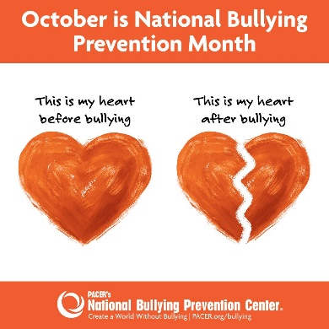
It’s aggressive, mean and potentially life-threatening. Bullying comes in many forms; none which are acceptable. Nearly 20% of US high school students have reported being bullied at school and 15% have reported being cyberbullied.
As a certified bullying prevention specialist and school counselor, I often teach about this topic to students, staff and families. One of the many ways I do this is to ask the question: Is it mean? Is it rude? Is it bullying? Unfortunately, there are many mean and rude people in the world. There are also bullies. The criteria for bullying includes being an ongoing act where there is a power difference and the intent is to harm. Check your local school system policy on how they define bullying in your area. The other item is technology and social media. Much of what happens at school has actually started with social media posts, tweets, and chats. Provide information to parents on how to protect their children in an unsafe online world.
Here are some ways your club can help:
Launch a community wide educational effort to focus on celebrating differences.
Practice empathy – a lost art in students today; help students learn how to reach out to those who appear to be struggling and to report bullying when you see it. One of the strongest ways to combat bullying is not to be a bystander but an upstander. Build a friendship bench for the playground.
Help teachers to reward students who show respect to others. Positive reinforcement works. Provide the rewards for classes.
Plan bully prevention programs. Sponsor and help pay for these programs. Ronald McDonald has one that may be free. The NED show is another good one where it can be free if the school sells merchandise. Clubs could provide this help.
Provide information to parents to understand the problem and know how to confront it.
Wear ORANGE on Unity Day (Oct 21).
Make social media posts. Find ideas here: www.pacer.org/bullying/nbpm/socialmedia
Run, Walk, Roll against Bullying – coordinate a local event in your community.
Register your organization as a Champion Against Bullying at pacer.org.
Take the pledge at www.pacer.org/bullying
Find more ideas at www.pacer.org.
5 Must Read Youth Adult Novels about bullying – sponsor a book club of the month in the school/local library (provide refreshments, do a lunch and learn, provide copies of the book): “Thirteen Reasons Why” by Jay Asher, “This is Where it Ends” by Marieke Nikamp, “A Piece of Heaven” by Angel Lawson, “Moxie” by Jennifer Mathieu and “The Outsiders” by S. E. Hinton.
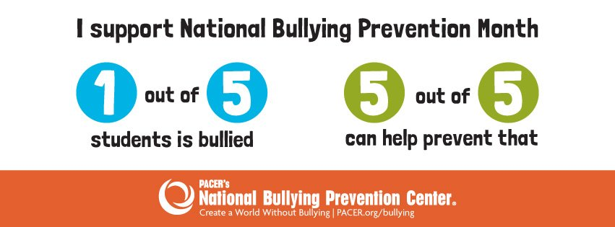
Awards! Awards! Awards!
In the next newsletters, watch for featured Top Ten projects in the upcoming newsletters.
Here’s the Club Creativity Project Honorable Mention from the GFWC Gallipolis Junior Woman’s Club of Ohio:
The GFWC Gallipolis Junior Woman’s Club created 25 days of Holiday Readings when Santa had to be quarantined. Various community partners, including Santa, read holiday stories to the community to promote literacy. There was a drawing each evening for viewers and five plus books were gifted each night with over 250 children receiving books throughout the 25 days.
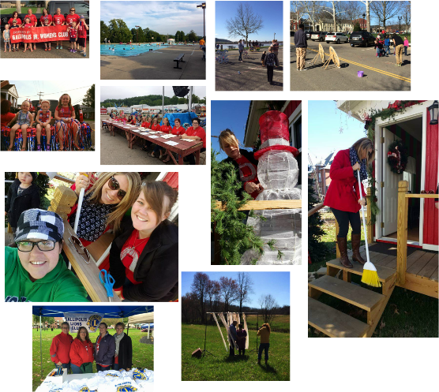
Change of Address: Please note if you plan to mail the Award Entry, my address has changed as of September 1, 2021 to Tina Neese, 1213 Main Street, Porterdale GA 30070. You are always welcome and encouraged to email me the report at tinadaniel1224@gmail.com.
You may also notice I have a name change! I will be married on October 2, 2021 and my name will go from Tina Daniel to Tina Neese. My email will remain the same for this administration.

