2022-2024 GFWC
LEADERSHIP COMMITTEE

Susan Gettys, Chairman
GFWC Mississippi Valley Region
susan.getts@att.net

Candi Aubin
GFWC Southern Region
aubin5@aol.com

Deb Brossard
GFWC Great Lakes Region
deb.brossard@gmail.com

JoAnn Calnen
GFWC New England Region
jcalnengfwc@cox.net

Jan Hanson
GFWC Middle Atlantic Region
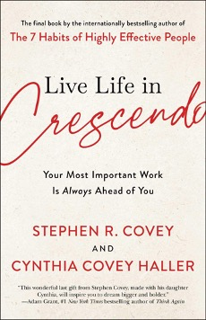
janwh@aol.com

Ann Landis
GFWC Southeastern Region
alandis@ec.rr.com

Betty MacMaster
GFWC Western States Region
macmaster@harbornet.com

Suzanne Simons
GFWC South Central Region
srsimons@mac.com

The next Leadership ESO Book is Live Life in Crescendo by Stephen Covey and Cynthia Covey Haller. Covey urges all to “live life in crescendo,” continually growing in contribution, learning, and influence. This crescendo mentality urges you to use whatever you have—your time, talents, resources, gifts, passion, money, and influence—to enrich the lives of people around you. We invite you to read this book and join us on December 11 for a Zoom book discussion. The Zoom link will be posted in the GFWC Advancements and Programs Forum on the day of the discussion.
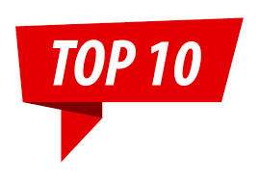 Building Leaders Through Encouragement
The president of GFWC Warren Woman’s Club (AR) led by example by adding encouraging notes or leadership quotes to the monthly meeting agendas so that members were always thinking about leadership and feeling appreciated. The president used the club newsletter to brag about specific members and their leadership potential and skills. She also asked members to fill certain roles rather than just hoping they would volunteer, and they said yes.
Check out the Member Portal for more Top Ten Projects from 2021.

PLANNING YOUR STATE LEADS

What topics do you want to feature in your State LEADS Program?
How about an “All Things GFWC” session focusing on our history, programs, and governance? Or “Public Speaking for New Leaders”? “Finding the Leader in You” might be helpful to help you grow your leaders. Resources to present these sessions will soon be added to the Leadership Toolkit, which can be found under L in the Member Portal. Keep checking back for additional resources.

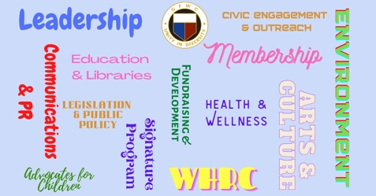

Have you joined the GFWC Advancements and Programs Forum in Facebook? Click Join at the top of the page and answer the membership questions. You will have access to a wealth of information posted daily.

Live video sessions are held on the second Tuesday and first Thursday of each month on Zoom and in the Forum and then posted in the Featured section at the top of the page.
Teach It Tuesdays will focus on information from Communications/PR, Leadership, and Membership Chairmen.
Thumbs Up Thursdays will feature other GFWC Chairmen or Board of Directors members.

Teach It Tuesdays began on September 13, with GFWC Membership Chairman Nancy Ames bringing you information on Member Retention. On October 11, GFWC Communications/PR Chairman Jen Nowak provided information about the importance of Branding.

Here is the schedule for upcoming sessions:

November 8 - Leadership – How to Create a Club Succession and Transition Plan
December 13 – Membership – Perfecting an Introduction to GFWC Club Work
January 10 – Filling Out Your Award Entry Forms (all 3 chairmen will present this)
February 14 – CPR - Canva 201 & Graphic Design
March 14 – Leadership – How to Create a Strategic Plan for Your Club
April 11 – Membership – Using Your Why to Recruit Members

On October 6, Thumbs Up Thursdays began featuring Juliet Casper, Legislation/Public Policy Chairman. Juliet shared information about the updated Legislative Action Center and the Legislative Scavenger Hunt.
The following sessions scheduled are:
November 3 – Donna Shibley, GFWC Writing Chairman
December 1 – Beth Smith, GFWC Community Impact Program Chairman

We are working on the Thumbs Up Thursday sessions scheduled after the first of the year. Keep your eyes on the GFWC Advancements and Programs Forum for updated schedules and the Zoom links to each program. You can join us through Zoom or on Facebook Live.

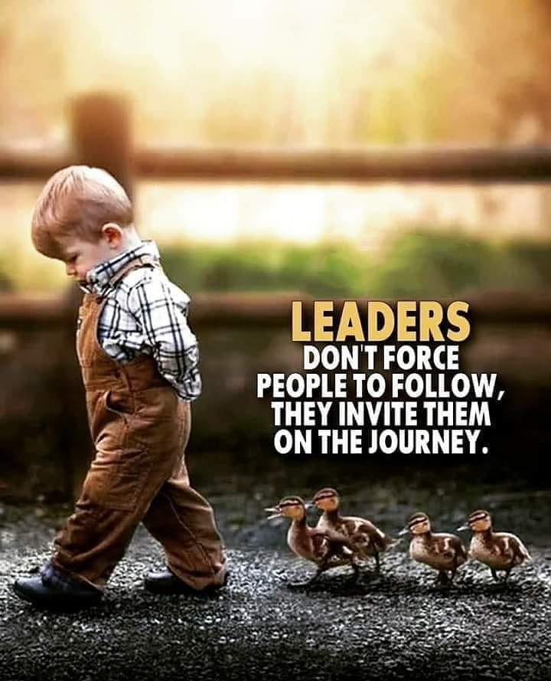

LEADS Applications
Due March 15, 2023
To Susan Gettys

Who will be the LEADS Candidate representing your state in Louisville, KY, on June 9, 2023? The LEADS Application can be found in the Member Portal under L (gfwc.org). The GFWC Leadership Committee is planning a fun-filled day of leadership information and activities, and we need your candidate there.

