GFWC 2020-2022 Education and Libraries

Chairman: Tina Neese, Ed.D., LPC

tinadaniel1224@gmail.com 678-458-0337
Volume Twenty Two May 2022 Newsletter

Inside this edition
- ESO Facebook
Group
- Featured Monthly Book
- Talk It Up
Tuesdays
- Well Read Wednesdays
- Honorary Chairman
Others news in this edition
- Book List Recommendations
- App Ideas
- Challenge Project
- Resources

Read All About It!

ESO Facebook Book Group
The Education and Libraries ESO Facebook Book Group meets online to discuss various books. There will be a featured book each month. The month of May features our last and final book read of the administration which is “And Ladies of the Book Club” by Helen Hoover Santmyer. During the month on Tuesdays, readers are encouraged to post their thoughts on our “Tuesday Chats” on the ESO private Facebook page, as well as participate in the live interviews and workshops presented by the author.

Not an ESO member yet? What do I do?
Request to be added to the GFWC 2020-2022 ESO Book Club on Facebook. Order or download your book. Read and discuss the book on the group page during the month. Join the 1,100 plus members on the page who are loving the chance to read together!

In May remember these dates:
Talk It Up Tuesdays – May 3, 10, 17 & 24
Participate in discussing our book of the month

Honorary Chairman

Jane Jenkins Herlong

Jane Jenkins Herlong is Education and Libraries’ honorary chairman for the 2020-2022 Administration. Jane is an author, inspirational speaker, and entertainer. Jane is also available to encourage our women with humor and wisdom through speaking engagements.

Jane has published four books: Rhinestones on My Flip-Flops, Bury Me with My Pearls, What Ta-tas Teach Us and Bare Feet to High Heels.

Wanting more of Jane? Invite her to your state or watch her videos, such as this one: Jane.
Jane has a new release as of April 2022: “Sweet Tea Secrets from the Deep-Fried South”. Find more about this book at Jane’s blog post at
https://janeherlong.com/the-baptist-church-bible-study-was-like-being-in-6th-gradeagain/.

May’s Book:
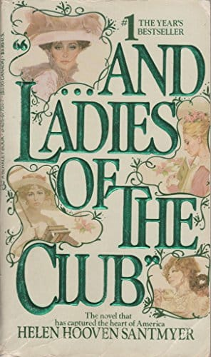
While intensely long, the reviews of this older book make it one worthwhile to stick with and read. Several members have commented on our Facebook of reading it years ago or re-reading it again and again.
The author was 87 years old when the book was published in 1984. Her wish had been to write a fictional story of a women’s book club that met for years where the women formed close relationships and reached out to better their community. Does this not sound exactly like our ESO and women club groups?

“That’s the thing about books. They let you travel without moving your feet,” Jhumpa Lahiri

At various times on the ESO Book Group Page on Facebook, there will be a book list released for members to review and add to their “TBR” list. Members can comment about books on the list, giving others an idea about the book.

It is May! Here’s some books to add to your spring reading list:

- Sea of Tranquility by Emily St. John Mandel
- The Candy House by Jennifer Egan
- The Immortal King Rao by Vauhini Vara
- Scoundrel by Sarah Weinman
- The Invisible Kingdom by Meghan O’Rourke
- True Story: What Reality TV says about Us? By Danielle Lindemann
- Anthem by Noah Hawley
- Olga Dies Dreaming by Xochitl Gonzalez
- To Paradise by Hanya Yanagihara
- How Civil Wars Start by Barbara Walter
- How High We Go in the Dark by Sequoia Nagamatsu
- Notes on an Execution by Danya Kukafka
- South to America by Imani Perry
- Vladimir by Julia May Jonas
- The Employees by Olga Ravn
- Thank you, Mr. Nixon by Gish Jen
STEM Activities for May!

May is all about Spring, Earth Day, school ending and Mother’s Day and is a great time to implement some fun STEM (Science, Technology, Engineering and Mathematics) activities with children.

Here are some fun activities to try during this month:

Try these Family Fingerprint Cards!
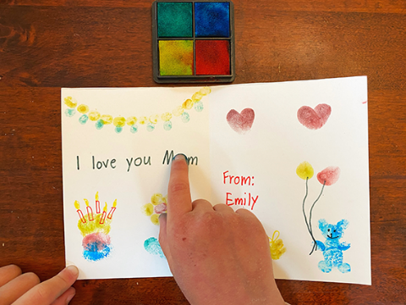https://www.sciencebuddies.org/stem-activities/succession-science-are-fingerprint-patterns-inherited?from=Blog

Or make these secret message cards!
https://www.sciencebuddies.org/stem-activities/invisible-ink?from=Blog

Make mom some fizzy bath bombs!
https://www.sciencebuddies.org/stem-activities/make-bath-bombs?from=Blog
ay Activities in the ClassroomAwards!
Technology App Monthly Recommendation:
The best nine technology apps for teachers
Google Drive
Calendly
Remind
Additio
Haiku
The TED App
Animoto
Explain Everything
Slack
Important Dates in May
May: Homeschool Awareness Month
May 1-7 National Postcard Week
May 1-7 National Pet Week
May 2-8 Children’s Book Week
May 2-6 Teacher Appreciation Week
May 15-17 National Police Week
May 16-22 National Transportation Week
May 1 May Day
May 1 Mother Goose Day
May 2 Holocaust Reembrace Day – read The Diary of Annie Frank or One Candle by Eve Bunting.
May 3 National Teacher’s Day
Write thank you notes to your local teachers. Sponsor a teacher breakfast, host a massage day during their planning time, or send a chocolate treat.
May 3 Space Day – the goal is to promote math, science and technology. Celebrate STEM this day by sponsoring space-related activities.
May 4 Star Wars Day – use action figures to inspire creative writing pieces
May 5 Cinco de Mayo – read stories and make a piñata!
May 6 No Homework Day
May 7 National Barrier Awareness Day
May 11 National School Nurses Day
Have a club drive to collect supplies a school clinic could use such as band aids, small paper cups, children’s underwear or single snacks.
May 9 Peter Pan
May 14 The start of the Lewis and Clark Expedition
May 15 National Chocolate Chip Day – celebrate by baking cookies and trying this fun chocolate bar math lesson https://www.thoughtco.com/delicious-way-to-teach-fractions-2081114
May 20 Weights and Measures Day
May 23 Lucky Penny Day
May 29 Paper Clip Day

National Barrier Awareness Day
May 7, 2022

This day is set aside as an annual observance to encourage people to break down obstacles responsible for preventing the social integration of persons with disaibilities. Its goal is to dissolve stigmas keeping people with disabilties from advancing in education, socially, in careers, or other spheres of life. It was initiated by President Ronald Reagan and began on May 7, 1986. Facts include childre of people with disabilties are affected and southern states have the highest rate (TX, FL, MS and other states along the southern coast).

How to observe: 1. Write possible policy suggestions to representatives. 2. Volunteer with organizations representing those with disabilties. 3. Show support on social media.

Children’s Book Week May 2 - 8
Children’s Book Week was established in 1919 and is one of the longest national literacy initiatives in our country. It started with the belief children’s books and literacy are life changers for young people.
Be involved with your school librarian to host a book week. Sponsor having each child receive a new or gently used book. Host a reading time with classes in the library.
Clubs can host a book challenge and present certificates available for free to students who complete the challenge.
Clubs can print off bookmarks for free from famous illustrators and present to schools.
Promote the week with social media posts.
Compile a list of books for each grade level, such as “Best Books for First Grade Students” and send it home with the kindergarten students to work on during the summer. Carry the week over by having the student read the books on the list for prizes when they return in August.
Host a book walk in your community for families to walk through the park or other designated area during the week. Have a kick off for your storybook walk and have club members dress in characters along the way. At the end of the book walk, have refreshments and free books or book marks.
Clubs can research and find fun, free stuff at the everychildareader.com website.

What’s a Book Walk or Story Walk?
A story walk is an outdoor reading experience where a children’s book is deconstructed. The pages of the book are laminated and placed on a stake along the walking trail.
This can be a fun and educational activity that can be placed anywhere in a community (schools, parks, city streets, or historic sites) with permission of the officials. It is perfect if your community is still mandating social distancing.
Here’s one book to use from Twinkl:
Around the World with Max and Lemon
Max goes on a journey to find someone just like herself. She travels around the world, meeting lots of new friends. She goes to the mountains, a desert, a jungle, the Artic, the ocean and an island. Each stop along the way in the book could be decorated to resemble the area. Club members could be dressed as a hiker, a monkey, a camel, fish, or in the tropics as the children take their book walk.
Find worksheets and postcard templates to use at the end of your walk at Around the World.
Other book ideas to use include Doris the Loris, The Bear who came to Babysit, or the Runaway Iceberg.
Find a great example at Brookfield Story Walk in Colorado: Story Walk.

