GFWC Environment  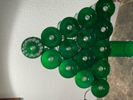  Winter Newsletter  Happy Holidays  Karen Martinek, GFWC Environment Chairman  karengfwc@gmail.com |  | Page 1 - december Environmental Dates  page 2 - JAN & Feb Environmental DATES, Deicing tips  Page 3 and 4 – October Recycling challenge  page 5 – Holiday recycling tips  Page 6 – energy SAVING TIPS  PAGE 7 – ENERGY saving and sustainable holiday gifts
Environmental Awareness Dates  December 4 – Wildlife Conservation Day  December 5 -International Volunteer  -World Soil Day  December 8 – World Climate Day  December 10- Human Rights Day  -International Animal Rights Day  December 11- International Mountain Day  December 14 - National Energy Conservation Day  December 15- United Nations Environment Organization Foundation Day  January  January 5- National Bird Day  January 10- Houseplant Appreciation Day  January 16- World Snow Day  January 29 – Seed Swap Day  February  February 2- Groundhog Day  -World Wetlands Day  February 9- World Marine Mammal Protection Day  -World Whale Day  February 27- International Polar Bear Day |  | Consider Making Your Own  Recyclable Wrapping Paper  THE MOST ECO-FRIENDLY WAY TO MELT SNOW AND ICE IN THE WINTER:  Shovel snow shortly after it falls, and do not allow it to accumulate or compact. You will also benefit from the exercise this provides.  We all want safe walks and driveways. Salt is damaging to the environment and pets.  When the ice and snow melt, the salt finds its way into our waterways affecting the plants and animals in our fresh water. No ice melting product is truly natural and earth friendly.  Consider using small amounts of sand, coffee grounds or sawdust, instead of deicer. Apply deicer sparingly if used and sweep up remnants after the ice melts.
October Recycling Challenge Outcome

Throughout October, GFWC clubs were asked to keep track of their plastic recycling habits to participate in the Reduce Plastic Use: Refuse, Reuse, Repurpose, and Recycle GFWC Challenge Project.
The reported results were amazing! For plastic bags - 17,405 were recycled, 7,421 reused, 1,361 refused, and 2,070 upcycled and made into items using plarn. For plastic bottles- 24,297 were recycled, 1,067 reused, 428 refused, and 194 upcycled. A special thanks to the State Federations that gave us these results: Alabama, Florida, Iowa, Michigan, Mississippi, Missouri, New Jersey, North Carolina, South Carolina, West Virginia, and Wyoming.
Thank you all for your efforts!!! I hope we learned a bit more about recycling and our own recycling habits after spending time thinking about how we used or recycled our plastics. I also hope you read some of our Social Media entries.
Together we make a difference!

There’s still more to do as we work together to demonstrate our concern for the health of our environment. Thanks for all the great pictures sent in. Here are just a few.

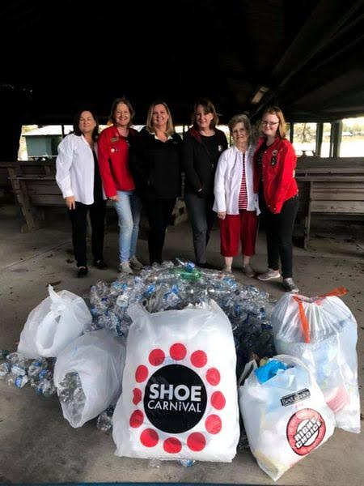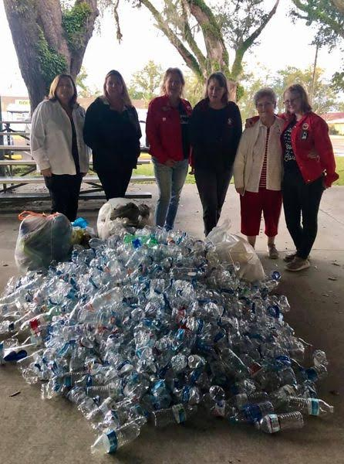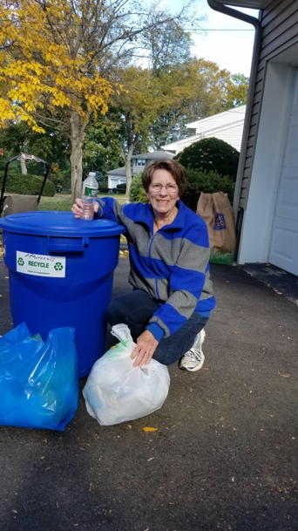
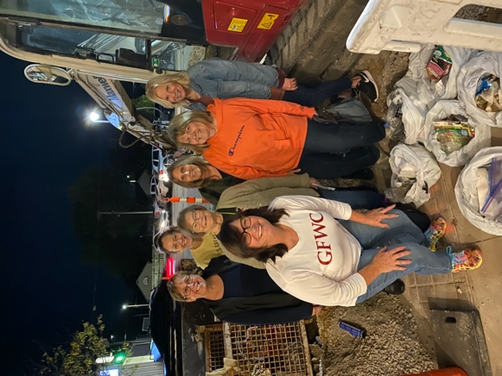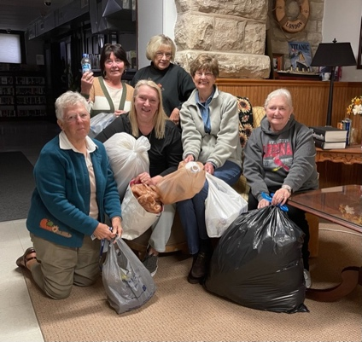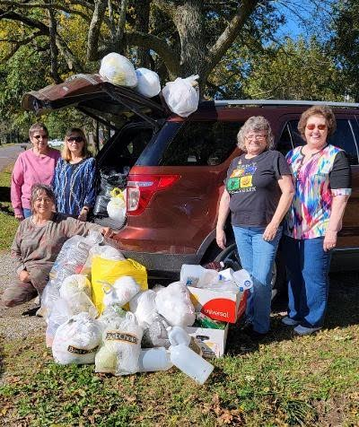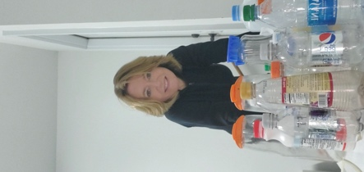
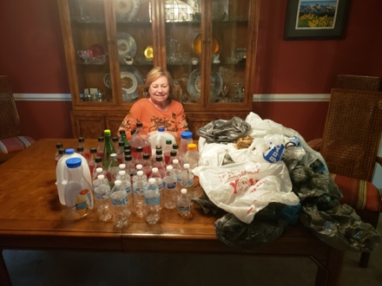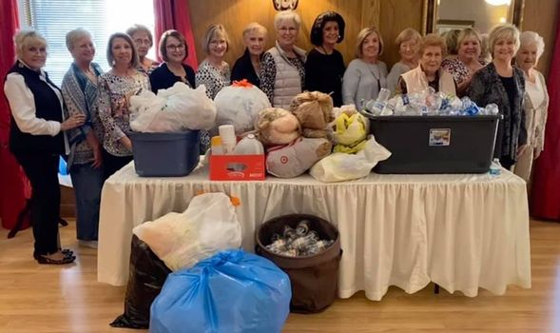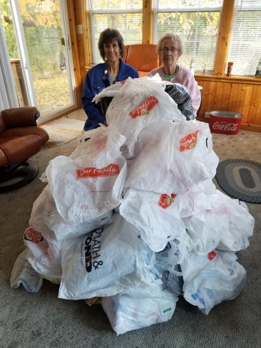

Holiday Recycling
- Much cardboard and packing products are used when ordering items online.
Make sure you recycle as much as possible, cardboard, paper packing, and air-filled plastic.
- Bubble wrap and Styrofoam, and Styrofoam peanuts, may be able to be recycled in certain locations. Reuse, these items, or put into the trash. Please contact your local recycle company and ask if there is a Styrofoam recycle deposit site near you.
- Wrap your gifts sustainably. Purchase wrapping paper made with recycled materials and that will also be recyclable. No foil, glitter or glossy paper. Consider making your own.
- Recycle correctly, rinse out food cans and bottles, dishwashing isn’t necessary
- Plant or compost your live Christmas tree.
- Put out the recycling bin during parties. Make it easy for guests to recycle their glass bottles and aluminum cans by putting the recycling bin next to the trash can.
Holiday Lights
Recycle broken or unwanted lights- most big box stores selling lights also recycle. Many communities set up recycling at their local recycle center, city office or grocery stores. Take advantage of these sites during this seasonal recycle effort. If no local deposit is available, you can ship your holiday lights to several Recycling Programs. Two are listed below.

Christmas Lights Source Recycling Program
4313 Elmwood Drive Benbrook, TX 76116
Holiday LEDS Recycling
W227N6225 Sussex Road, Door #12
Sussex, WI 53089

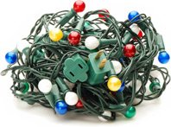

Energy Saving - LED Holiday Lights
Energy.gov gives the following energy saving information regarding LED lights.
LEDs consume far less electricity than incandescent bulbs. This includes decorative LED light strings. Not only do LED holiday lights consume less electricity, they also have the following advantages:
- Safer: LEDs are much cooler than incandescent lights, reducing the risk of combustion or burnt fingers.
- Sturdier: LEDs are made with epoxy lenses, not glass, and are much more resistant to breakage.
- Longer lasting: The same LED string could still be in use 40 holiday seasons from now.
- Easier to install: Up to 25 strings of LEDs can be connected end-to-end without overloading a wall socket.
Alliant Energy PowerHouse U-Tube plugged in an old string of incandescent lights and a string of LED lights and compared the power that each used. Their conclusion was that the LEDs that were lit for 5 hours a day for 30 days cost just .16 a string compared to $5.93 for a string of incandescent lights used for the same time period.

Energy Saving and other Sustainable Holiday Gift Ideas

- Think outside of the box with holiday gift-giving.
- Use your power of consumer choice when purchasing gifts.
- When deciding on what to get your loved ones for the holidays, consider experiences over products. Gifting an experience, like concert tickets or a weekend getaway reduces waste and is generally seen as less unfavorable and results in longer-lasting happiness than material possessions. This may be because it is more unique.
- Gift a National Park Pass or a donation in the recipient’s name to their favorite charity.
- Shop sustainable products. When shopping for your holiday gifts this season, consider that products that are made with ocean plastic, reused fibers, or recycled paper.
- Give the gift of a tree, an actual tree or planting a tree in a loved one’s name. Give through Arbor Day, Trees Forever, Nature Conservancy or another local opportunity.
- Smart Thermostat- you can program the thermostat to save when you aren’t home
- LED Light bulbs - help make the change throughout the entire home
- Solar powered phone chargers and toys - Save on electricity or batteries
- Advanced Power Strips - They sense when electronics aren’t in use and turns off- reduces standby or phantom energy consumed when electronics aren’t in use.

Have a Healthy & Sustainable Holiday Season
