A Healthy Smile
By Beth Smith, Health and Wellness Community Service Program Chairman
From GFWC News & Notes ~ February 3, 2022 edition

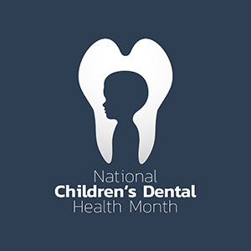
Some people cringe at the thought of going to the dentist, but I love how my teeth feel after a good cleaning. Many of our mothers insisted on dental visits when we were children, which taught us the value of taking care of our teeth and gums.
Dental health is a key component of overall health. Untreated cavities can cause pain and infections that may lead to problems with eating, speaking, playing, and learning.
Participate in National Children’s Dental Health Month this February, promoted by The American Dental Association (ADA) to raise awareness about the importance of oral health.
The ADA has free online resources that can help clubs with oral health presentations, ideas for the classroom, and activity sheets that can be used as handouts. Print these activity sheets and make dental health packets by adding toothpaste, a toothbrush, and floss for your club’s National Children’s Dental Health Month project. Take these packets to underserved schools, children’s clubs, daycares, and churches.
And remember to share this advice during your outreach: "you don't have to brush your teeth, just the ones you want to keep."

