Hands on Leadership in Your State Federation

Congratulations! You are a grassroots leader of one of the largest women’s volunteer organizations. Leaders like you are a vital part of community action and are essential for the success of the General Federation of Women’s Clubs as a whole. You can succeed as a leader, knowing that your national and state federations provide ALL you need to engage your club members in volunteer work that is beneficial and enjoyable.

Being present at state events is the best way to ensure your club:
- Gets the important information they deserve as GFWC members.
- Is represented by you, the club delegate, voting on resolutions and bylaws that affect your members.
- Learns about many important initiatives they can support.
- Feels connected and important in their role as a GFWC club.

Watch for information on these important events:
Club Leader’s Day ~ Held in August or September. As President your club counts on you to attend to gather information from the state and national federation for planning club meetings and projects. Calendar of events, contests, scholarships, and other materials are reviewed.

State Meetings (Fall Meeting, Midwinter Meeting, Annual Meeting) ~
As a club delegate you are key to the quorum needed for business at state meetings. Annual Convention includes awards, recognitions, and officer installation (even calendar year). Share the Call (invitation with Registration Forms, emailed to Presidents) to these meetings with your members in a timely manner, so members can participate. All members are Welcome and encouraged to attend.

Federation Day at the Forest ~ Loved ones and friends may be remembered at this June event by donating at least $15 to Headquarters along with the form. Names are read at the ceremony. Encourage club memorials to share in the stewardship of our Memorial Forest.

Participation in other events such GFWC New England Region Conference and GFWC International Convention is always encouraged. Informative speakers, leadership workshops, advocacy and networking with fellow clubwomen can be a memorable part of your journey as President.

Taking Care of Business ~ The Beat of the President

As Club President you are expected to coordinate various state requirements for your club such as completing yearly statistical information and Manual Sheets.

Calendar ~ When planning club activities make every effort to minimize conflicts with federation events. The federation calendar containing all state and national dates is available online at www.gfwcma.org or contact the Headquarters Secretary.

Contribution Forms ~ The GFWC MA Club Contribution Form (mailed in the fall) should be sent to Sudbury Headquarters received by December 31 with one check for the total of all donations selected on the form. The Club Contribution Form provides a convenience for both the State Treasurer and the Club Treasurer. Many clubs support the Arts scholarships, as well as Headquarters and Memorial Forest funds, which are not endowed. Clubs can also donate to GFWC Partners. The GFWC MA Treasurer collects contributions from clubs throughout the state and forwards them as one state donation. Clubs are recognized for their contributions at the Annual Convention.

IRS 990 Form ~ For your club to maintain its non-profit status be sure your club files a 990tax form with the IRS each year, by the 15th day of the 5th month after the close of your tax year. Be sure the password needed for the form is passed along to the incoming president and club treasurer. The form found at www.IRS.gov with filing instructions generally only takes minutes to complete. NEW! A current copy should also be on file with GFWC MA Headquarters.

Manual Sheets ~ Manual Sheets are due at Headquarters by June 1 each year. These are used to update club contact information and calculate member dues which are billed each year in November and due to GFWC MA in December. Manual Sheets are available on the state website and are also sent by the Headquarters Secretary in May each year to the Club President on record.

Statistical Form and Club Reports ~ Your club’s accomplishments are the very heart of GFWC volunteerism. It is important to complete the GFWC MA Statistical Form and simplified project reports. Mail to Headquarters by January 31. Visit www.gfwcma.org for instructions and to download the forms.

Be in the know

Who should receive a copy of your club yearbook? As a courtesy, one copy of your club yearbook should be sent to GFWC MA Headquarters to be kept on file.

Who receives Federation Topics? This state newsletter is issued electronically approximately four times a year directly to Club Presidents who are expected to forward the electronic edition to all club members.

How can I get GFWC promotional brochures? Full-color GFWC Massachusetts Membership brochures are available from state headquarters. They may be used in conjunction with GFWC brochures (available from the GFWC Marketplace (http://www.gfwc.org/membership/marketplace/) and your own club brochures. Let others know about GFWC Massachusetts!

What does GFWC offer for member recognition? Outstanding women in your club should be recognized. Regular thank you mentions at meetings and thank you notes from you personally go a long way toward retaining members. For clubwomen who have been members for 5, 10, 25, 30 years you may purchase Recognition Pins from the Marketplace ($5.00 each) at www.gfwc.org. Gold pins for 50 year members are available free online.

President Pins are available at the GFWC Marketplace
www.GFWC.org for $10.00. Arrange for purchase in advance
to be presented to the incoming president at her installation.

Can members still be honored with a brick for GFWC MA Headquarters Unity Pathway? Yes. An honorarium for both living and deceased clubwomen is available for the brick path in front of Sudbury Headquarters. Form online. Cost for a 4" x 8" brick is $60 for 2 lines, $70 for 3 lines; an 8" x8" brick is $125 for 5 lines.

How can I help my club members feel connected to GFWC?
- Familiarize yourself with the National organization as presented at www.gfwc.org
- Find the GFWC Club Manual online. Download and share project ideas from GFWC Program Chairmen and Partners.
- Forward GFWC’s weekly e-newsletter News & Notes to your members; to subscribe contact GFWC@GFWC.org.
- Share your copy of Clubwoman Magazine (free as Club President)
GENERAL FEDERATION OF WOMEN’S CLUBS
OF MASSACHUSETTS
Donna M. Shibley, President
2020-2022

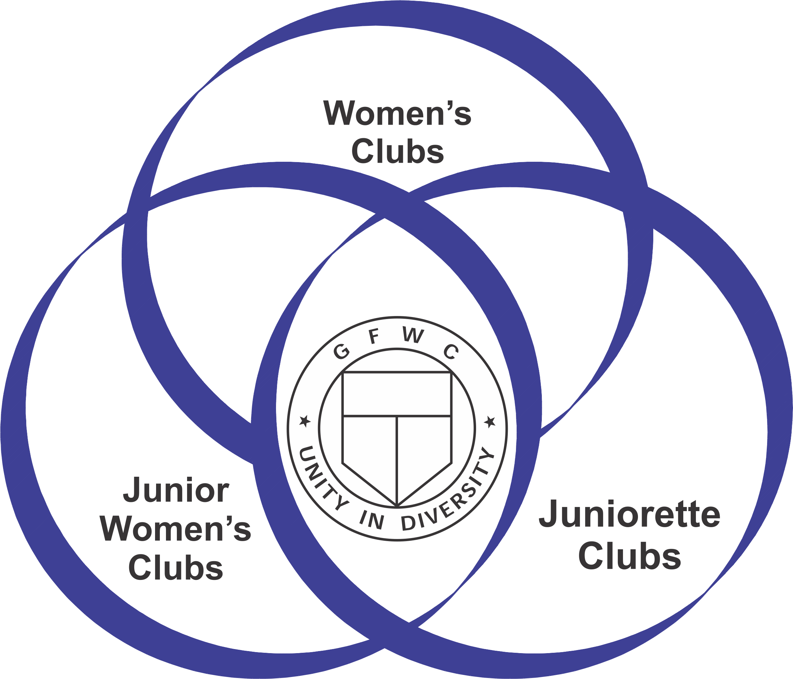

Hearts & Hands for GFWC

Club Presidents
HANDBOOK

Helping YOU help your CLUB

Contact your Federation Headquarters at:
PO Box 679
Sudbury, MA 01776-0679

located at:
245 Dutton Road
Sudbury, MA 01776-0679

Office: 978-443-4569
Email: HQSecretary@gfwcma.org
Visit: www.gfwc.org and www.gfwcma.org

