Marisa Jablanski
Director of Junior Clubs
Director@gfwcma.org
Phone: 508-335-1007

Sheila E. Shea Junior Club President Award
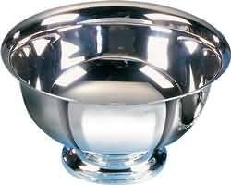

This award is given to the club president who demonstrates strong leadership skills, while sharing and encouraging the work of GFWC within her club. She is attentive to administrative aspects of the position of club president such as reporting and submitting Manual sheets and other requested information to Junior Membership and GFWC of Massachusetts. She attends Junior Conferences and events and encourages her members to attend as well. She is a proud representative of her club and is welcoming to all members.

All club nominees will be recognized at the
GFWC Massachusetts Annual Convention
Saturday, May 6th, 2023

Entry Rules
- The following information must be included:
- Name of club president or co-presidents being nominated
- Name of club
- Dates of service
- Name, title, and contact information of officer submitting nomination
- Each club is allowed ONE entry.
- Former state winners of this award are not eligible for re-nomination.
- Entries must be typed, double spaced and no more than two (2) pages.
- Entries must be sent to the membership chairman via USPS or email at information above. If emailed, please send as an attachment; a confirmation receipt will be sent. If mailed, please include a cover page with your club name and president’s name and two (2) print copies of the entry.
- All entries must be received or post marked by March 1, 2023.

