___________________________________________________________________

The WHRC Messenger Volume 2, Issue 1, Page 1
___________________________________________________________________

GFWC Women’s History and Resource Center Committee

Hope Royer, Chairman Mary Baird Carolyn Forbes
700 Hermitage Road 11 Quail Hollow Circle 1591 Autumn Moon Lane
Manakin Sabot, Virginia 23103 Sandwich, Massachusetts 02563 Magnolia, Delaware 19963
804-784-0820 508-566-0398 302-222-6468
hoperoyer@aol.com bairdmaryc@gmail.com mrschefdjf@aol.com

*******************************************************************
GFWC clubs in every state are preparing to begin in September what many of us call the “new club year”. The 2021 September meeting will be even more special than most. For many of us, it will be the first “in person” meeting since the early Spring of 2020.
You might want to share this anecdote from the summer issue of the WHRC Newsletter with your WHRC Chairmen and clubs:
The Indianapolis Woman’s Club was organized by seven women in 1875. Laura Giddings Julian was elected president. Mrs. Julian’s young daughter Grace shared the excitement of her mother’s first club meeting in a note written to her cousin Kate:
“Mama wore her black lace bunting dress and her English walking hat, also her silk dolman and dark green kid gloves, also a red geranium with a rose-geranium leaf pinned on her waist. She looked very nice. Bedford took her in the carriage and he had to wash the carriage first. It didn’t get quite dry, but Mama said she must not be late at the club because she was president. But she was late after all, because Meg lost a shoe. So, Mrs. McKay (secretary) had to start the club.”
Gone are the days of hats and gloves and horse drawn carriages. Welcome, all to the start of the 2021 2022 club year!

*******************************************************************
If you’ve not already subscribed to the WHRC Newsletter, please do! Published quarterly by the members of the GFWC WHRC Committee, the WHRC Newsletter is distributed electronically, without cost. Timely, interesting and informative Federation and women’s history topics vary from issue to issue. In the 2021 summer issue you will learn about book wagons and the ESO, meet GFWC’s Alice Lakey and Julia Lathrop and tour Atlanta’s historic Wimbish House, headquarters of the Atlanta Woman’s Club. Contact Carrie deGuzman, GFWC Director of Communication, at cdeguzman@gfwc.org, to add your name to the list of subscribers.

___________________________________________________________________

The WHRC Messenger Volume 2, Issue 1, Page 2
___________________________________________________________________

Many of your clubs are looking for some “new” women’s history projects. Why not add these to their lists? The GFWC WHRC Committee has just recently added a scripted, PowerPoint presentation to the list of members-only WHRC Resources. The presentation “This Old House” was originally prepared in celebration of the 30th Anniversary of the opening of the Women's History and Resource Center. It has been updated to provide an "armchair tour" of our magnificent, historic home. Both the PowerPoint slides and historical narrative document are available in the Member Portal Digital Library. The presentation is particularly appropriate as GFWC approaches the celebration of the 100th anniversary of the purchase of its International Headquarters located at 1734 N Street in Washington, DC.
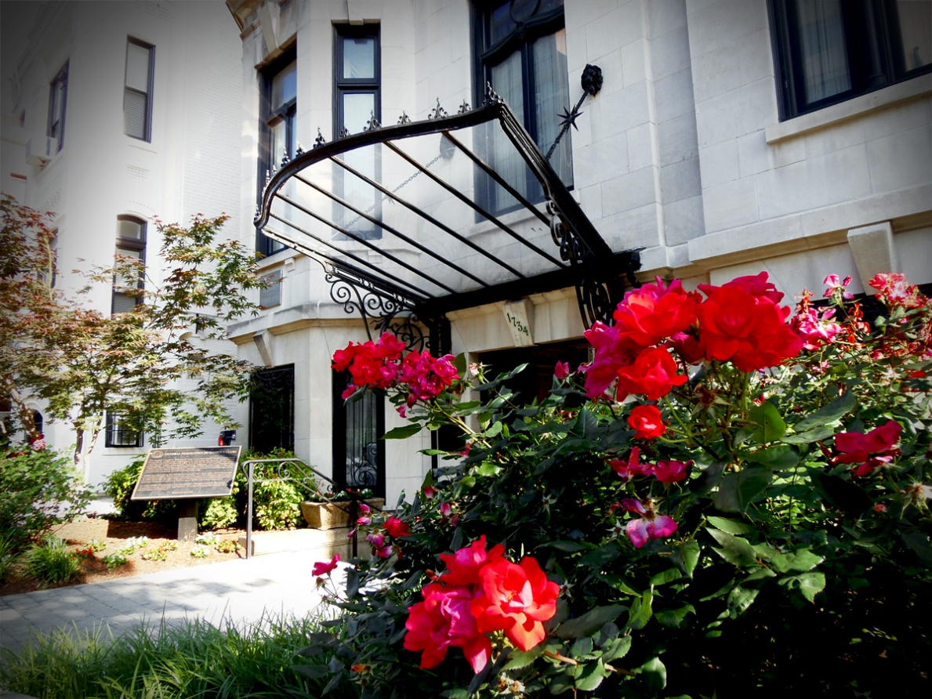

Whoever doesn’t know the past must have little understanding of the present and no vision of the future.”

