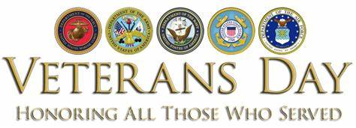

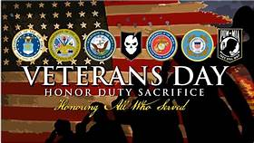
Veterans Day originated as “Armistice Day” on Nov. 11, 1919, the first anniversary of the end of World War I. Congress passed a resolution in 1926 for an annual observance, and Nov. 11 became a national holiday beginning in 1938. Unlike Memorial Day, Veterans Day pays tribute to all American veterans—living or dead—but especially gives thanks to living veterans who served their country honorably during war or peacetime.
When Is Veterans Day?
Veterans Day occurs on November 11 every year in the United States in honor of the “eleventh hour of the eleventh day of the eleventh month" of 1918 that signaled the end of World War I, known as Armistice Day.
In 1954, President Dwight D. Eisenhower officially changed the name of the holiday from Armistice Day to Veterans Day.
In 1968, the Uniform Holidays Bill was passed by Congress, which moved the celebration of Veterans Day to the fourth Monday in October. The law went into effect in 1971, but in 1975 President Gerald Ford returned Veterans Day to November 11, due to the important historical significance of the date.
Veterans Day commemorates veterans of all wars.
Great Britain, France, Australia and Canada also commemorate the veterans of World War I and World War II on or near November 11th: Canada has Remembrance Day, while Britain has Remembrance Sunday (the second Sunday of November).
In Europe, Great Britain and the Commonwealth countries it is common to observe two minutes of silence at 11 a.m. every November 11.
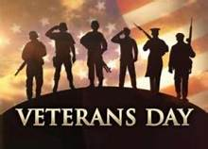
Every Veterans Day and Memorial Day, Arlington National Cemetery holds an annual memorial service. The cemetery is home to the graves of over 400,000 people, most of whom served in the military.

Veterans Today
The military men and women who serve and protect the U.S. come from all walks of life; they are parents, children, grandparents, friends, neighbors and coworkers, and are an important part of their communities. Here are some facts about the veteran population of the United States:
18.2 million living veterans served during at least one war as of 2018.
9 percent of veterans are women.
7 million veterans served during the Vietnam War.
3 million veterans have served in support of the War on Terrorism.
Of the 16 million Americans who served during World War II, about 496,777 were still alive as of 2018.
Connecticut was home to the highest percentage of World War II veterans as of 2018 at 7.1 percent.
- 2 million veterans served during the Korean War.
- As of 2017, the top three states with the highest percentage of Veterans were Alaska, Maine and Montana, respectively.
Information copied from https://www.history.com/topics/holidays/veterans-day-facts

