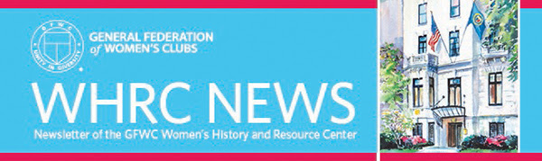
Fall 2022
WHRC COMMITTEE & STAFF
Chairman: Celene Post
Committee Members: Mary Kaye Ernest, Carla Pyle
International President: Debra Strahanoski
WHRC Librarian: Joanna Church

Meet Your 2022-2024 WHRC Committee!
Celene Post, Chairman
Celene has been a member of GFWC for 35 years in Wisconsin and Arizona. She is currently serving as the GFWC Women’s History and Resource Center Chairman. After several chairmanships she served as GFWC-AZ President from 2016-2018. She has served on the 125th GFWC Anniversary Committee, Public Issues Community Service Program chairman, and Strategic Planning Committee member.
In addition to several committee/program chairmanships in Wisconsin, she served as Wisconsin Director of Junior Clubs (1984-1986) and chaired the 1986 HOBY seminar.
Celene retired in 2017, after 43 years in Health Care, the last 17 with Banner Health. Deciding she was not ready for 24/7 bonding with her retired husband, Rex, she used her nursing skills to care for the elderly and those on Hospice Care.
Celene has four adult children and 7 grandchildren, ages 17-31. Before moving to Spokane, WA, her daughter Jen was also a member of GFWC Las Noches Woman’s Club. She enjoyed their time together in volunteer service to others.
Carla Pyle
Susan Carla Pyle was born in Wilmington, Delaware and has lived there all of her life except for when husband Jeff was assigned to the National Security Agency at Fort George G. Meade in Maryland. She and Jeff have been married 53 years and have two grandchildren. In her “underutilized spare time” Carla enjoys family and friend gatherings, quilting, sailing, and reading. Weekends and summers find Carla and Jeff on their beloved sailboat Wings, sailing the Chesapeake Bay.
In addition to teaching middle school for 31 years, Carla has had a lifetime of volunteerism in her church, school, and community organizations, including HOBY (Hugh O’Brien Youth Leadership Seminar); ARC of Delaware; the Town of Odessa Historic Commission; Winterthur; and the Historic Odessa Foundation, where she created the Historic Odessa Volunteer Program and was responsible for volunteer development, marketing, training, and overseeing day-to-day operations. She is most proud of this accomplishment.
Carla joined the Women’s Club of Odessa in 1999 and has served on the GFWC Delaware Bylaws Committee, as Community Improvement Program Chairman, and as Education CSP Chairman. Elected positions include DSFWC Recording Secretary, Vice President, President Elect, and GFWC Delaware President, 2018-2020. She received the Charlotte Emerson Brown Award for Outstanding Leadership from GFWC in 2020. In 2021 she was nominated by her club and selected for the GFWC DSFWC Jennie Award, and her name was sent on to the Region and to GFWC. She is involved in the Middle Atlantic Region (MAR) and the GFWC as a member of the 2020-2022 GFWC Signature Program and the 2022-2024 WHRC Committees.
Mary Kaye Ernest
Mary Kaye Ernest, a lifetime resident of Wisconsin, has been married to Donald for 48 years, and is mother of four awesome children and grandmother of five. While her children were growing up and in school, she was President to the PTA at an elementary school, middle school, and overall PTA committee for the District, which also afforded her the opportunity to be active on the Wisconsin State PTA Board. Growing up, she never thought that over half of her life would be spent in a volunteer capacity.
After joining her local GFWC Junior Women’s Club, she worked her way up to State Junior Director GFWC Junior Board. From there she moved on to Wisconsin State Chairman of several departments, State President of Wisconsin, and on to GFWC Great Lakes Region President. After her presidency was complete, she served as a Committee member to several GFWC Committees, Chairman for the Writing Program, and International Liaison Committee for two terms. She has also joined the GFWC Florida Clubwomen in participating on a service project to Belize.
Mary Kaye and her husband love cruising, which has also afforded her the opportunity to visit several GFWC clubs in the Caribbean and to participate in several International Affiliate Clubs celebrating special anniversaries.
Volunteering has always been an important part of her life and she looks forward to new challenges of volunteering within GFWC and other areas.
Meet Your WHRC Librarian!
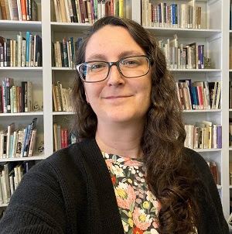
Joanna Church
Joanna joined GFWC as WHRC Librarian in late August 2022, picking up the reins from the many dedicated staff and volunteers who have worked to maintain and share the organization’s historic archives and collections. A Maryland native, she has a Bachelor’s degree in Anthropology from Grinnell College (IA) and a Master’s degree in Museum Studies, concentrating on cataloging and registration, from the George Washington University (DC). With over twenty years of experience in small museums, and a love for women’s history and stories, Joanna is looking forward to growing the WHRC collection, building on its strengths, and working to make it more accessible both online and in-person. Questions? Interested in working on your club or federation history? Thinking of things you might want to contribute to the WHRC collection? Get in touch! Joanna can be reached at 202-683-2028 or jchurch@gfwc.org.
Visiting the Turning Point Suffragist Memorial
By Carla Pyle, WHRC Committee
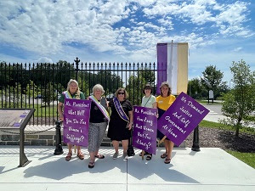
Each year in August the GFWC Board of Directors gathers in Washington, DC for an annual meeting, and 2022 was no exception. As members of that body, the Women’s History and Resource Center Committee was included in the weekend activities and tour. The tour took us to Turning Point, the Suffragist Memorial in nearby Fairfax County, Virginia.
The design of the memorial includes 19 stations that tell the story of the 72-year-long struggle to pass the 19th Amendment, which granted many (though not all) American women the right to vote. A wall commemorates the names of the women who were jailed at the Occoquan Workhouse, near the site of the memorial. They were horribly mistreated, but that did not stop the movement. Rather, this event became the 1917 "turning point" in the suffragist movement and thus the name Turning Point for the memorial. At the entrance to the memorial is a piece of the fence which stood in front of the Wilson White House where the picketers were arrested. Lifesize bronze figures honor three suffragist movement leaders: Alice Paul (author of the Equal rights Amendment); Mary Church Terrell (co-founder of the NAACP); and Carrie Chapman Catt (President of the National American Woman Suffrage Association and founder of the League of Women Voters).
Our own Deb Strahanoski (at the time, GFWC President-elect) was present for the dedication of the memorial on May 16, 2021. A donor wall shows the contributors to the memorial, many of which are GFWC Clubs, State Federations, and individual members. In fact, GFWC is credited with a large portion of the funding for the site. We should all be proud of this contribution to assuring that this part of our history is memorialized.
Over 80 Board members went to see the memorial on that very hot August day. As hot as it was, it provided a few moments for each of us to reflect on the dedication of these women to accomplish what they did, and to admire their strength to endure when their journey seemed like it would never end. As we returned to DC it was with a renewed sense of dedication to GFWC and making a difference in our communities as these suffragists did in our country. It also gave us an increased sense of the need for GFWC to continue to support the Women’s History and Resource Center, housed at headquarters at 1734 N Street NW. It is important to continue to tell our story through the collection of the WHRC.
GFWC State Federation Anniversary Celebrations
By Celene Post, WHRC Committee Chairman
Congratulations to......GFWC Delaware State Federation of Women’s Clubs (DSFWC) on their 125th Anniversary!
On May 5, 1898, the newly formed Delaware State Federation of Women’s Clubs held its first Annual Convention in Dover, DE. In the early years, many felt the “Ladies Clubs” were social in nature. Yet from the beginning, the Delaware Federation worked for mandatory education, libraries, prison reform, health care, and other civic issues.
One of the dominant issues was securing the right to vote through the passage of the 19th Amendment to the United States Constitution, ratified in 1920. During the years of the Depression in the 1930s, a DSFWC program provided food, clothing, and housing assistance to those in need. World War II brought new focus to the clubwomen of Delaware. They instructed meetings on civil defense; nurses were needed, so clubs earmarked scholarships for nursing programs.
Conservation and environmental stewardship have also been a focus of clubs. They supported a bill to protect and preserve state forestlands. Clubwomen continue to encourage recycling and controls on emissions from industries in the state.
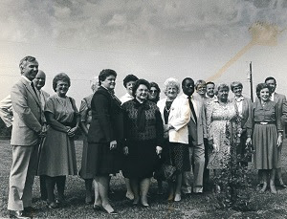
Members of the GFWC Delaware State Federation of Women’s Clubs and the Twentieth Century Club of Smyrna (DE) joined school staff to plant holly trees on the lawn of Smyrna High School as part of the Delaware Centennial celebrations of 1987. From the GFWC Regional, State, and Local Club History collection
This past May, Delaware clubwomen gathered for the 125th Annual Convention with the theme, “Celebrate our Past and Forge our Future.” The WHRC Committee congratulates you on 125 years of service to your communities! Wishing you continued success for another 125 years!
National Hispanic Heritage Month
National Hispanic Heritage Month (September 15 - October 15) may be over, but that doesn’t mean the celebration of the achievements of Hispanic and Latin Americans needs to end! Established as a week-long event in 1968, it was expanded in 1988 to a full month, using September 15th – the anniversary of independence for Costa Rica, El Salvador, Guatemala, Honduras, and Nicaragua – as the starting date. GFWC joins many organizations around the country in honoring Latinas and Hispanic American women in history and today.
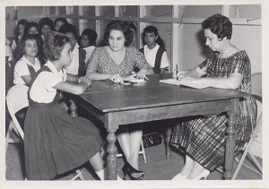
The Women's Civic Club of Puerto Rico’s Community Improvement Program for 1962-1964 was to develop artistic, recreational, and cultural activities for twenty-five students at Asenjo Junior High School. To successfully complete this project, the club asked local teachers, Girl Scouts, the Asylum for the Blind, and women of various faiths to share their talents and experiences with the girls. From the GFWC Community Improvement Projects collection, 1962-1964 administration
Further afield, there are many other resources celebrating Hispanic heritage all year long. Read about Cuban artist Ana Mendieta’s career on the Smithsonian American Women’s History Museum website. Speaking of the Smithsonian, you can also visit the website for the planned National Museum of the American Latino.… Check out the National Women’s History Museum’s online exhibit “Women Run, Women Win: Latinas in Congress.” … And visit the National Women’s History Alliance website to learn more about women like Ana Roqué de Duprey (1853-1933), Puerto Rican educator and suffragist; Lucy Gonzalez Parsons (ca. 1853-1942), labor organizer and radical socialist; Tania Léon (b. 1943), composer and conductor; Vicki L. Ruiz (b. 1955), educator and pioneer in Latina history; and Ellen Ochoa (b. 1958), the first female Hispanic astronaut.
Donate to WHRC
The WHRC News is a quarterly newsletter highlighting GFWC collections, club histories and anniversaries, and topics of interest in women's history. If you’ve enjoyed this edition, please consider participating in the GFWC Annual Giving Program and including the Friends of the WHRC in your donation. This fund supports the purchase of preservation supplies, collections management technology (such as the upcoming improvements to our online catalog), books for the WHRC research library, and outreach to students, teachers, and scholars. Help the WHRC preserve the history of GFWC and the contributions of its clubwomen!
Donate Online
Checks
Include "WHRC" in the memo line, and make payable and send to:
GFWC
1734 N Street NW
Washington, DC 20036-2990
Unsubscribe from WHRC News
Don't want to receive WHRC News any longer? Log in to your personal profile on the GFWC Member Portal and uncheck "WHRC News" in the list of message types that you are currently receiving.

